BRITISH SKEWBALD AND PIEBALD ASSOCIATION
COMPANY LIMITED BY GUARANTEE REGISTERED IN ENGLAND NO 367 1904
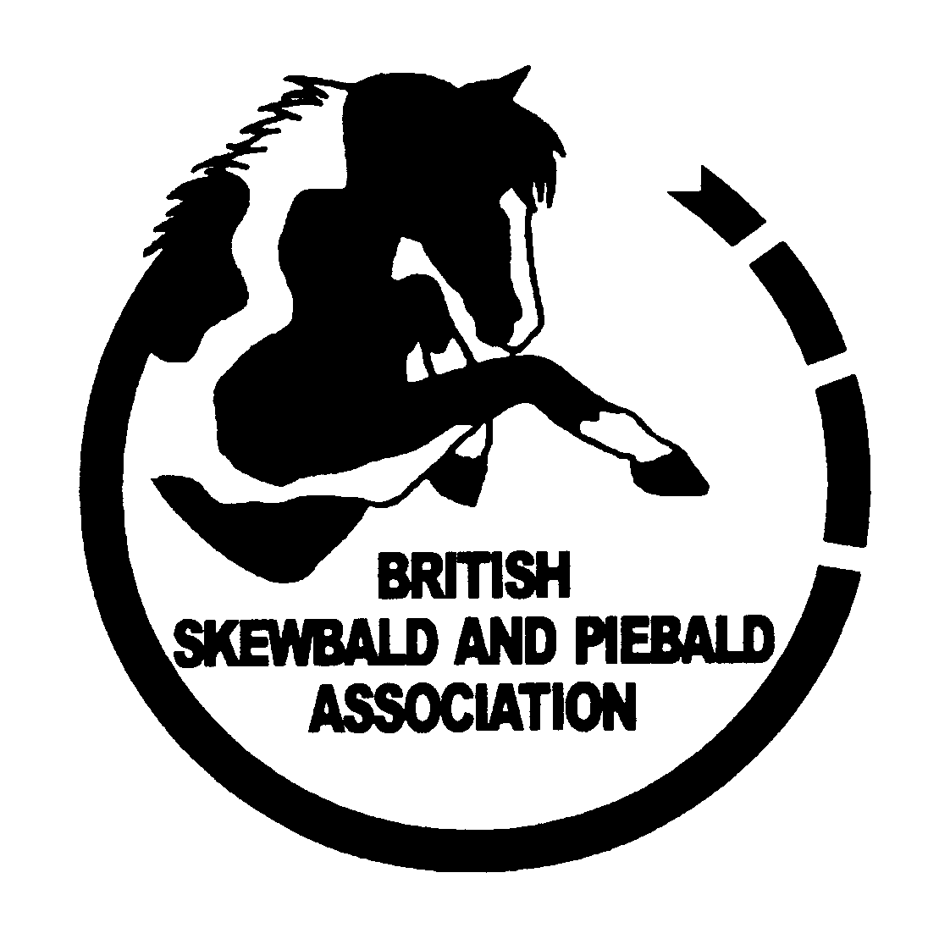
WORLD CHAMPIONSHIPS OF COLOUR
SUMMER CHAMPIONSHIP 2024

AFFILIATION FORMS
SEND TO:
BSPA SHOW AFFILIATIONS
STANLEY HOUSE
SILT DROVE
TIPPS END
WELNEY
WISBECH
CAMBS PE14 9SL

AFFILIATED SHOW NAME, WEBSITE AND EMAIL ADDRESS

TELEPHONE: 01354 638226 - 07411121106
E-MAIL: bspashows@gmail.com
WEBSITE: www.bspaonline.com

PAYMENT DETAILS:- CHEQUES PAYABLE TO BSPA
Bacs (receipt required) DETAILS BSPA HSBC WISBECH 40-20-38 a/c 21123785
SHOWS AFTER 1ST AUGUST WILL QUALIFY FOR WCC 2025
WORLD CHAMPIONSHIPS OF COLOUR 2024
CHAMPIONSHIP QUALIFICATION CLASSES
THE FOLLOWING WORDING MUST BE USED IN ALL SCHEDULES:
BSPA CLASSES ARE OPEN TO SKEWBALD AND PIEBALD HORSES AND PONIES ONLY
OPEN TO MEMBERS AND NON MEMBERS. MEMBERS ONLY TO QUALIFY FOR WCC

THESE CLASSES ARE AFFILIATED TO THE BRITISH SKEWBALD AND PIEBALD ASSOCIATION AND ARE QUALIFIERS FOR THE WORLD CHAMPIONSHIPS OF COLOUR NATIONAL CHAMPIONSHIP SHOW.
ALL CLASSES WILL BE JUDGED WITHIN THE RULES AND CRITERIA OF THE BSPA. COPIES OF THE RULEBOOK AND MEMBERSHIP/HORSE REGISTRATION/OVERSTAMPING FORMS CAN BE OBTAINED FROM SHOW OFFICE 01354638226 OR DOWNLOADED FROM www.bspaonline.com
ALL STALLIONS 4 YEARS AND OVER MUST BE GRADED LICENSED AND REGISTERED WITH BSPA IN ORDER TO COMPETE,BSPA BRIDLE DISCS TO BE WORN). TO IN ORDER TO QUALIFY ALL OWNERS/HANDLERS/RIDERS MUST BE MEMBERS OF THE BSPA AND ALL HORSES/PONIES REGISTERED WITH BSPA PRIOR TO THE SHOW.
BSPA QUALIFICATION CARDS MUST BE PRODUCED IN THE RING AND BE SIGNED BY THE JUDGE, OTHERWISE QUALIFICATION IS INVALID.

ALL SHOWS HELD AFTER 1ST AUGUST 2024 ARE QUALIFIERS FOR WCC 2025
QUALIFICATION 1-3 IN ALL CLASSES OR 1-4 FOR CLASSES EXCEEDING 12

IN HAND CLASSES: CHOOSE FROM ANY OF THE FOLLOWING

TICK BOX TO INDICATE WHICH CLASSES YOU HAVE SELECTED | THESE NUMBERS ARE FOR BSPA OFFICE USE TO IDENTIFY CLASSES | DESCRIPTION OF CLASS  AND  CLASS WORDING
 | 1 | BSPA INHAND YOUNGSTOCK QUALIFIER. SKEWBALD AND PIEBALD HORSE OR PONY 1, 2, AND 3 YEAR OLDS ANY SEX TO BE PLAITED. NO FOALS
 | 2 | BSPA INHAND YOUNGSTOCK QUALIFIER SKEWBALD PIEBALD HORSE OR PONY NATIVE TRADITIONAL AND COB 1, 2, AND 3 YEAR OLDS ANY SEX TO BE SHOWN NATURAL STATE OR HOGGED. NO FOALS
 | 3 | BSPA INHAND QUALIFIER ANY AGE HEIGHT OR SEX (ALL STALLIONS MUST BE GRADED WITH BSPA AND WEAR THEIR BSPA STALLION ID DISC AT ALL TIMES) TO BE SHOWN PLAITED. NO FOALS
 | 4 | BSPA INHAND QUALIFIER. SKEWBALD AND PIEBALD HORSE OR PONY ANY AGE HEIGHT, SEX (ALL STALLIONS MUST BE GRADED WITH BSPA AND WEAR THEIR BSPA STALLION DISC AT ALL TIMES) TO BE SHOWN NATIVE, TRADITIONAL OR HOGGED. NO FOALS
 | 5 | SPORTS HORSE /PONY YOUNGSTOCK QUALIFIER 1,2 AND 3 YEAR OLDS NO FOALS  SUITABLE FOR THE DISIPLINES OF SHOWJUMPING, EVENTING OR DRESSAGE  A. PONY YOUNGSTOCK COLT, FILLY OR GELDING ESTIMATED NOT TO EXCEED 153CMS AT MATURITY  B. INHAND SPORTSHORSE YOUNGSTOCK COLT FILLY OR GELDING EXCEEDING 153CMS  ALL EXHIBITS MUST HAVE A VERIFED PARENTAGE PASSPORT

RIDDEN CLASSES: CHOOSE FROM ANY OF THE FOLLOWING

 | 6 | BSPA SKEWBALD AND PIEBALD RIDDEN NOVICE HORSES OR PONIES IN THEIR FIRST SEASON OF COMPETITION OR NEVERTO HAVE WON 2 FIRSTS (JUDGE WILL NOT RIDE) ANY SUITABLE SNAFFLE BRIDLE MAY BE WORN  JUDGE WILL NOT RIDE
 | 7 | BSPA SKEWBALD AND PIEBALD COMBINED CLASS HORSE/PONY ANY TYPE HEIGHT, COLOUR OR SEX  JUDGE WILL NOT RIDE.
 | 8 | RIDDEN SPORTSHORSE/PONY  SUITABLE FOR THE DISCIPLINES OF SHOWJUMPING, EVENTING OR DRESSAGE.  4-8 YEARS STALLION, MARE OR GELDING  ALL STALLIONS MUST BE GRADED WITH BSPA  ALL EXHIBITS MUST HAVE A VERIFIED PARENTAGE PASSPORT. JUDGE WILL NOT RIDE

WORKING HUNTER CLASSES:

 | 9 | BSPA SKEWBALD OR PIEBALD WORKING HUNTER QUALIFIERS MAY BE OBTAINED FROM ANY OPEN WORKING HUNTER CLASSES BEING RUN AT YOUR SHOW THREE HIGHEST PLACED SKEWBALD/PIEBALD STANDING 1-6 WILL QUALIFY (MUST BE INDICATED ON THE SCHEDULE)

CHILDRENS RIDDEN CLASSES

 | 10 | THE TWO HIGHEST PLACED SKEWBALD OR PIEBALD IN ANY OPEN LEAD REIN OR FIRST RIDDEN CLASS AT YOUR SHOW WILL QUALIFY ( MUST BE INDICATED ON THE SCHEDULE)

PLEASE ENCLOSE THE FOLLOWING

- COMPLETED AFFILIATION FORM
- DRAFT SCHEDULE USING THE WORDING INDICATED bspashows@gmail.com
- NAMED BSPA PANEL JUDGE
- CHEQUE PAYABLE TO BSPA
- COPY OF PUBLIC LIABILITY INSURANCE
- SEND SCHEDULE TO BSPA OFFICE NO SCHEDULE MUST BE PRINTED WITHOUT APPROVAL FROM BSPA. SEND A COPY OF YOUR SCHEDULE TO THE SHOW OFFICE. bspashows@gmail.com
- TO BE JUDGED WITHIN THE RULES AND CRITERIA OF BSPA
- ALL RESULTS TO THE MEDIA OR POSTED ELECTRONICALLY MUST BE PREFIXED BSPA WCC
- BSPA RULE BOOK AND JUDGES PANEL bspaonline.com WILL BE SENT WITH ROSETTES AND RESULTS SHEET. RESULTS SHEETS MUST BE RETURNED WITHIN 7 DAYS OF THE SHOW.
- PLEASE RETURN FORMS IMMEDIATELY
- CONTACT US: TEL 01354 638226 / 07411121106 E-MAIL bspashows@gmail.com
ADDRESS: BSPA AFFILIATIONS STANLEY HOUSE SILT DROVE TIPPS END WELNEY CAMBS PE14 9SL
RESULTS MUST BE SENT TO bspashows@gmail.com
WITHIN 7 DAYS OF YOUR SHOW.
ANY CHANGE OF JUDGE MUST BE NOTIFIED ON YOUR WEBSITE AND BSPA OFFICE MUST BE INFORMED IMMEDIATELY 01354 638226 TEXT 07411121106

BRITISH SKEWBALD AND FEES SENT YES/NO

PIEBALD ASSOCIATION

SEND TO: STANLEY HOUSE SILT DROVE TIPPS END WELNEY

WISBECH CAMBS PE14 9SL TEL: 01354 638226
E-mail bspashows@aol.com
PLEASE FILL OUT FULLY IN BLOCK CAPITALS
RETURN THIS FORM ONLY TO BSPA OFFICE WITH THE FEE

SHOW AFFILIATION REQUEST FORM BSPA 2024

Name of Show:
County: Postcode:
Date of Show: | Closing Date for Show:
Show Office Details  Tel:  Fax:  Email:  Website: | Contact Name/Address for show Sec and Postcode:
JUDGE (MUST BE ON BSPA PANEL)
2024 rule book will be sent to you or you can download from www.bspaonline.com
SUMMARY OF QUALIFYING CLASSES SELECTED
In-Hand | ◻✓ Yes  How many classes | Ridden | ◻✓ Yes  How many classes | Ridden  continued | ◻✓  How many classes
1 |  | 6
2 |  | 7
3 |  | 8
4 |  | 9
5 |  | 10
 |  |  |  | RIHS 2
 |  |  |  | RIHS 4
- Fees: Combined BSPA WCC+ RIHS 2 Classes £90 - RIHS 4 Classes £110
- Fees: WCC Fees £10 per class or £30 6 classes or more
CHAMPIONSHIP ROSETTES REQUIRED; INHAND YES/NO RIDDEN YES/NO

- Fees BSPA £20 OR £25 for3 or more classes: BSPA 3yr plan £45/£60 refer BSPASL6.

- Fees BSPA £25 refer BSPASL6 for 3yr plan BSPA only £60
- Fees combined BSPA/RIHS £50/60 refer BSPASL5/6
Please make cheques payable to B.S.P.A. Shows.
I confirm the above Classes have been selected and will be listed as Qualifiers for the BRITISH SKEWBALD AND PIEBALD ASSOCIATIONS WORLD CHAMPIONSHIPS OF COLOUR. I will use the required Wording as listed
Signed--------------------------------------------------Show Secretary

